Accessible Tactile Graphic Printer

Proposal

Design Team 8: Bryan Cotton, Caroline Kerbelis, Changqing Yang, Eman Aljabr, Martez Steverson, Maram Sulimani



Sponsor: Resource Center for Persons with Disabilities
Faculty Facilitator: Hassan Khalil

2/21/14

Executive Summary
The purpose of this project is to design, fabricate, simulate, test and demonstrate a specialty printer that will be used to produce tactile graphics and maps for visually impaired students at MSU. Ideally this printer will produce more durable images and be more feasible than current specialty printers available commercially.
Table of Contents

Introduction………………… …..…………………………………………………………………………..…1
Background………………………………………………………………………………………………….…1
Design Specification..……...…….…………………….……………………….…………………………..….1
Mission Statement………………………………………………………………………………………....1
Objectives.......…………………………………………………………………………………………….2
FAST Diagram……………....………….……………….……….……………………………………….……3
Conceptual Design..…………………………...…………………………………….………………………....3
Ranking of Conceptual Designs…………………………………………………………………………….….5
Proposed Design…………………………………………………………………………………………….….6
Hardware………..………………………………………………………………………………………....6
Software…………………………………………………………………...………………………………7
Risk Analysis…..…………………………………………...……………….….…….………………………...7
Project Management Plan……………...…...………………………….……..…………………………….…..8
Roles………………………………………………………………………………………………………8
Resources and Facilities……….………………………………………………………………………….9
Timeline………...…………………………………………………………………………………………9
Gantt Chart……...……………………………………………………………………………………......10
Budget…….………………...……………….……………………………………….……………………….11
References…………………….……………...…...………………………….…………………………….....13

Introduction
Tactile graphics and Braille are an essential component to making education accessible to the visually impaired. Currently there are several methods of producing tactile graphics, the most commonly utilized method is the embossing of Braille paper by solenoid activated pins. What this actually entails is altering the surface of a particular substrate or paper stock by providing a three dimensional or raised effect on selected areas. The Resource Center for Persons with Disabilities (RCPD) on MSU’s campus currently preserve two tactile graphic embossers that produce pictures, charts and drawings to assist blind students in their studies. The downfall to these embossers however, is that the images that it produces are quite frail and are eventually pressed down after repeated use which in turn makes it difficult for a blind student to identify the image. Thus, the team has been assigned the responsibility of designing a specialty printer that can be used to produce 11x17in tactile graphics and maps for blind users/students at MSU. If successful, a duplicate design will be created for a school for the blind in India. This designed tactile graphic printer should produce more durable images and cost significantly less. To enable independent use by blind students, the idea of adding a voice feedback feature is also being explored.

Background
While 3D printing has been around since the 1980s, it wasn’t until the early 2010s that the printers became widely available commercially. This type of printing technology is used for both prototyping and distribution manufacturing with applications in architecture, construction, industrial design, as well as automotive and aerospace among others (3D Printing: Mashable). 3D printing also known as additive manufacturing is a process consisting of making a solid three-dimensional object of ideally any shape from a digital model (Additive: Rapid). This form of printing is achieved by using an additive process, where successive layers of material are added to a surface in different shapes to create a particular object, figure or graphic. The image is created using a Computer-Aided Design program (CAD) and then saving this file as a STereoLithography (STL) file. The file is then transferred to a g-code generator program such as slic3r which converts the file containing the image into a set of instructions/language that the printer understands. The 3D printer under computer control, uses an extruder which moves along a x, y, and z axis extruding a filament (plastic material) onto a surface creating the object through sequential layering. There are several projects and companies that are making efforts to develop affordable 3D printers for consumer use. Much of this work has been driven by and targeted at “Do It Yourself’ (DIY)/enthusiast communities. RepRap, one of the front runners in developing these projects, aim to produce a free and open source software (FOSS) 3D printer, which is capable of replicating itself by printing many of its own (plastic) parts to create more machines. With the RepRap design serving as an inspiration, many related projects are contributing to an ecosystem of related or derivative 3D printers, most of which are also open source.

Design Specification
Mission Statement:
The purpose of this capstone design project is to construct a specialty printer that is capable of creating tactile graphics and/or maps to be used as resources by blind persons at Michigan State University. The end result will produce a long-lasting tactile graphic image that can withstand repeated physical stress over an extended period of time.

Objectives:
Must be satisfied:
- Low cost: For this design to be considered a success, the final printer must cost well below current commercially available devices such as embossers and 3D printers. We will aim to keep our design under $1000 USD in an effort to meet this requirement. This requirement is of the utmost importance.
- Durable final product image: The tactile graphic image that the printer produces must be able to withstand repeated use over a period of time. Paper will not be sufficient for our purposes. The material that the graphic is comprised of must be a type of plastic.

- Large image: The end result image created must be large enough for users to distinguish various lines and shapes as well as scale and various object heights. While we do want a large image, we still want it to be portable for ease of use by the end user.

Increase Desirability:
- Voice feedback: It is desirable for a blind person to be able to use the printer without assistance from others. For this purpose, voice feedback should be integrated into the design to enable the user to hear the various instruction options as they are selected. This addition would highly improve the desirability of the final project design.
- Easily reproducible printer design: Our design will be documented so that if it is desired, a duplicate device will be made to be used by the Asian Aid School for the Blind in India. Therefore, our design should be comprised of easily accessible and relatively inexpensive parts and technologies.
- Elastic deposited material: The material that is deposited should be elastic to enable use of Michigan State University’s IV EO touchpad and to provide more flexibility than current tactile graphics allow.

FAST Diagram
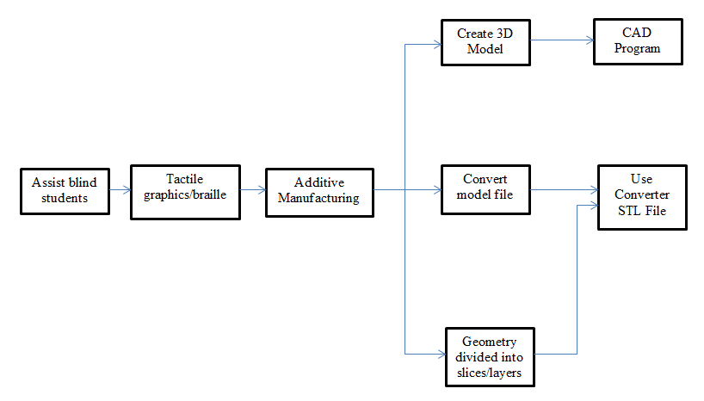
Conceptual Design
There are two methods for designing a specialty printer that can be used to create tactile graphics and maps: subtractive and additive manufacturing technology. Subtractive manufacturing can be defined as the process of removing layers of a workpiece (e.g. rock or a block of wood) to create a 3D model. This technology has been present since the 1940’s. However, in the past 20 years, it has gone through dramatic changes. It is now smaller, faster and much more reliable (EM). The team considered using two types of subtractive machines: benchtop millers and engravers.
Benchtop Millers: In this method, high-speed rotary cutters are used to remove layers from the workpiece by feeding it towards the blades. Benchtop millers usually contain a worktable that feeds the workpiece, and a motor-driven spindle that rotates the cutter (Machining: Wikipedia). Figure 1 below shows the schematic for benchtop miller.
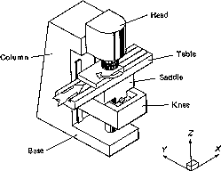
Figure 1. Benchtop Miller

Engravers: This method works by incising a design or an image into a solid surface (usually flat) by cutting grooves into it. Like the benchtop miller, the main components are a worktable and a spindle that holds the blades of the cutter (Machining: Wikipedia). An example of an engraving machine is shown below in figure 2.
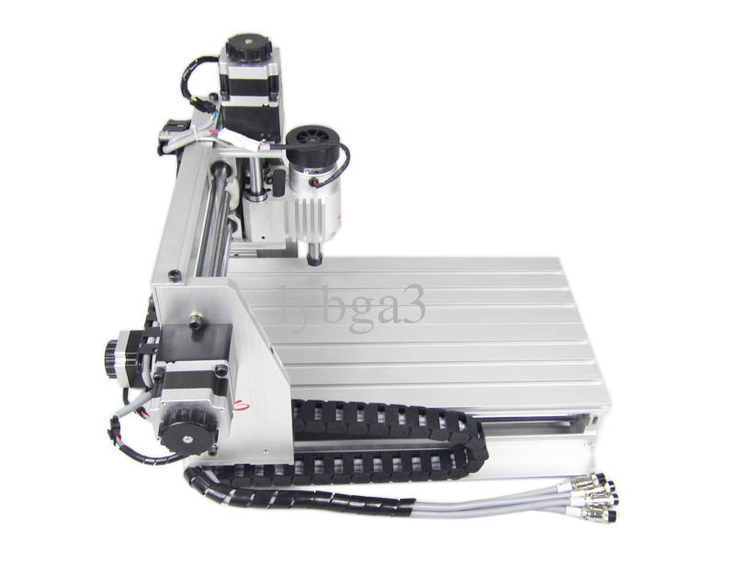
Figure 2. Mini Engraving Machine
On the other hand, additive-manufacturing technologies can be defined as the process of adding layers of a particular material on top of each other to create a 3D model. Additive manufacturing is a more recent technology. It was first introduced in the 1980’s and developed throughout 1990’s (EM). The team considered using four types of additive machines: Fused Deposition Modeling (FDM), Electron Beam Freeform Fabrication (EBF), Laminated Object Manufacturing (LOM) and Stereolithography (SLA).
Fused Deposition Modeling: FDM works by extruding material (i.e. the filament), one layer after the other to create the desired prototype (see figure 3). This machine usually contains a frame that holds all the electrical components, an extruder that dissipates the material, a heatbed for the prototype and a microcontroller that handles the software (Fused Deposition Modeling: Wikipedia).
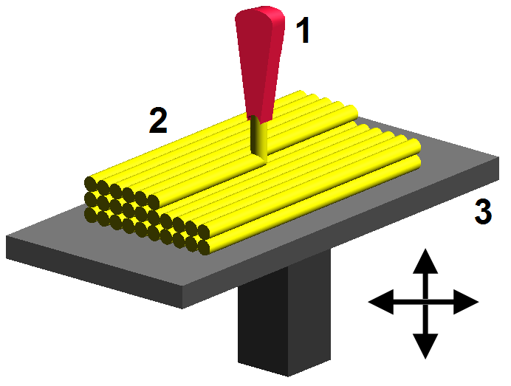
Figure 3. Fused Deposition Modeling
Electron Beam Freeform Fabrication: EBF was designed by NASA to build complex 3D objects. It uses electron beam energy sources and wire feedstock to complete the work (see figure 4). In this method, the main material used as a filament is aluminum and titanium (Electron Beam Freeform Fabrication: Wikipedia).
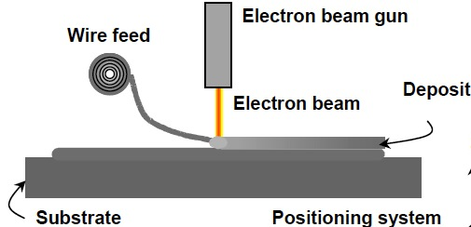
Figure 4. Electron Beam Freeform Fabrication
Laminated Object Manufacturing: In this method, the layers of the filament (paper, plastic or metal) are laminated together by using pressure and heat and then cut to the desired model by a knife or a computer controlled laser cutter(see figure 5). Using a drill or an engraver after the printing can also further develop the model (Laminated Object Manufacturing: Wikipedia).
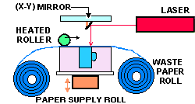
Figure 5. Laminated Object Manufacturing
Stereolithography: SLA works by curing a vat of liquid photopolymer resin with an ultraviolet laser to solidify the model, one layer at a time. This method has two main advantages: a very high precision and short lead-time (Stereolithography: Wikipedia). Figure 6 below shows the schematic for laminated object manufacturing.
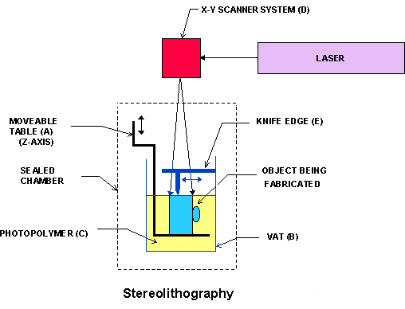
Figure 6. Laminated Object Manufacturing

Ranking of Conceptual Designs
Table 1. Below is the first decision matrix for all the considered design options:
Each of the possible designs below are rated 9:Strong, 3: Moderate and 1:Weak

Table 1. First Decision Matrix
Engineering  Criteria | Possible Solutions
Engineering  Criteria | Subtractive Manufacturing |  | Additive Manufacturing
Engineering  Criteria | Benchtop milling | Engravers | FDM | EBF | LOM | SLA
User friendly | 3 | 3 | 9 | 3 | 9 | 9
Reliability | 3 | 3 | 9 | 9 | 3 | 9
Software Support | 3 | 3 | 9 | 3 | 3 | 3
Speed | 3 | 3 | 3 | 9 | 3 | 3
Space | 3 | 3 | 3 | 3 | 3 | 3
International Support | 3 | 3 | 3 | 3 | 3 | 3
Lifespan | 9 | 9 | 3 | 9 | 3 | 9
Effectiveness | 3 | 1 | 9 | 9 | 3 | 9
Flexible Output | 1 | 1 | 9 | 1 | 3 | 3
Cost | 1 | 1 | 3 | 1 | 3 | 1
Weight | 1 | 1 | 3 | 1 | 3 | 3

Discussion: Each team member came up with a conceptual design that falls under either additive or subtractive manufacturing technologies. While each conceptual design has its advantages, some had more disadvantages than the others. For instance, as can been seen in table 1, some were less reliable: benchtop millers, engravers and laminated object manufacturing machines. Meanwhile, the rest of the designs were strongly reliable. Most of the conceptual designs were very effective. However, there are few criterias for the design that the team could not compromise. For instance, the cost of benchtop millers, enravers, stereolithography and electron beam freeform fabricators is exponentually high, which, in return, made it impossible for the team to even further investigate that design. Also, another important critiria was the size of the output; if the conceptual design is not capable of producing a large output, the design should not be further investigated. Table 2. Below is the second decision matrix which only shows the feasble designs with the importance score for each critiria:
Each of the criterias below are rated on 1-5 scale.

Table 2. Second Decision Matrix
Engineering Criteria | Importance | Possible Solutions
Engineering Criteria | Importance | Additive Manufacturing
Engineering Criteria | Importance | FDM | LOM
User friendly | 3 | 9 | 3
Reliability | 4 | 9 | 3
Software Support | 4 | 9 | 3
International Support | 3 | 3 | 3
Effectiveness | 5 | 9 | 9
Reusable output | 5 | 9 | 9
Lifespan | 3 | 3 | 3
Flexible Output | 5 | 9 | 9
Cost | 5 | 3 | 3
Total Points |  | 267 | 201

Proposed Design
After considering all the possible design options and comparing the total points, it was clear that FDM was the most feasible design. In comparison to LOM, FDM is more reliable, user friendly and has a better software support. An example of an FDM machine is 3D printers. Thus, the team decided to design a 3D printer with the main purpose of serving as a specialty tactile graphic printer. To build this custom 3D printer, the team decided that it would be best to purchase all the parts needed and build the printer from scratch. A breakdown of the hardware and software systems can be found below:
Hardware:
One of the most important parts in the tactile graphics printer is a strong frame since stability of the printing process is required for the accuracy of the output. The team decided to use a basic mechanical kit to build the frame to support the movement and hold the machine together. With the ShapeOko kit, the team was able to resize the printable area to the specified size. For movement of the printer, four stepper motors were needed; three for x, y, and z axis and one for the extruder movement. The extruder is the head of the printer that contains and extrudes a filament onto a flat surface one layer after the other creating the required image. An 11x17in double strength oven glass is used as the printing surface to avoid breaking and warping under the extreme heat. In addition, a heated print bed is required to warm the glass surface to ensure the first layer of the image will be stable an increase the accuracy of the output. For the plastic material, the team decided to use ABS filament for its flexibility and durability. The printer will receive images via Secure Digital (SD) card that is powered by SMART Liquid-Crystal Display (LCD) controller. The compatibility between the microcontroller and ramps electronics kit is of high importance, therefore an Arduino Mega 2560 microcontroller will be installed to control the printing process and functions of all the electrical components. The printer is powered by 110V AC to 12V DC 10-Amp power supply (see figure 7).
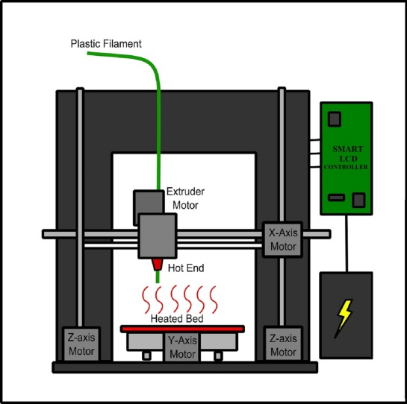

Figure 7. 3D Printer Schematic

Software:
The image will be created using a CAD program such as Google SketchUp, AutoCAD, or SolidWorks. Then, it is saved as a gray image by saving this file as a STL file. This image will be sliced into a two-dimensional mask image then converted into a set of machine instructions (G-code) and stored in the SD card. Finally, the printer will receive the instructions and perform the designated task required to create the requested object.
Testing the design will consist of ensuring the stability of the frame, the accuracy of the images, the performance of all the electrical components, and the durability of the material. The design will be successful as achieving all the functions has been tested.

Risk Analysis
After conducting preliminary analysis as well as research, several possible challenges and concerns arose. These challenges ultimately stem from providing adequate ventilation and cooling during the printing process as well as sufficient power and compatibility of electrical components. There are researchers that claim 3D printing could cause health risks. When printing using ABS material, there is usually a smell of hot plastic. Researchers also identified that the operation of such devices in unventilated areas could potentially lead to health issues which is of high risk. ABS and PLA polymers as a plastic feedstock were classed as “high emitters” of ultrafine particles (UFPs), reporting similar emission rates to the burning of a cigarette (Brian). As a direct result of the size of UFPs, they can be deposited in the lungs and absorbed directly into the bloodstream. High concentrations of UFPs have been linked to lung cancer, strokes and the development of asthma symptoms. In order to avoid this health risk, proper ventilation shafts and filters to evacuate airborne particles should be ensured while printing.
Another risk of moderate concern is the overheating of the hot ends (J-Heads) on the tip of the extruder during the printing process. The hot ends must reach very high temperatures in order to melt the filament used during printing, thus they may be subject to excessive heating which can ruin the creation of the particular image or figure. To prevent this from occurring, a proper cooling system must be installed on the printer such as a fan.
In addition, the power supplies selected must be able to provide sufficient voltage and amperage to all of the electrical components to prevent the printer from stalling or shorting while it is carrying out the designated print function. Also, the microcontroller utilized to serve as the brain and control all of the functions of the 3D printer, must be compatible with the ramps electronics kit as well as the stepper motors and drivers. This is potentially a high risk because these components are essential in the development of the 3D object and failure to ensure compatibility will compromise the overall functionality of the printer.

Project Management
Roles:

Caroline Kerbelis – Management
The role as manager has responsibility for the group and communication with the sponsor. The customer requirements were needed to be met and tracking of groups progress towards the critical path. Personally designating weekly meetings as a group and to the facilitator and responsibility with assigning the technical roles of each group member based on experiences/strengths.
Technical role: Ideas included the use of a heatbed. Worked on the designed for a headbed using glass, PCB and thermal insulator, with the idea of using two PCB heatbeds by Maram. After more deliberation designed a less expensive heatbed with a griddle and 11 x17 glass sheet for more even heat coverage and less cost. Also experimented with CAD to design small 3D solid image with braille with Division of Engineering Computing Services.
Bryan Cotton – Web Design
The role as web designer creates the team website, which will include pages for the project overview, description, gallery, documents, and information about the team members.
Technical role: Extensive research and development of printed image. Ideas included the use of creating a 3D digital model using CAD and Google SketchUp. Brain also researched the LCD controller that will be used in the project.
Changging (Alex) Yang – Document Prep
Responsible for ensuring each deliverable has all of the necessary information, such as final proposal and final report. Maintain document standards and organization.
Technical role: Research of extruder and filament options, such as Acrylonitrile butadiene styrene (ABS) and Polylactic acid (PLA) and investigation of filament types and printing them on plastic sheets.
Maram Sulimani – Presentation Prep
The role as presentation prep coordinates oral communication for team presentation and preparation of the poster for design day.
Technical role: Research of software, such as finding softer to convert the 3D digital model to gCode by using Slic3r software. Research into the frame stability and feasibility of using the Shapeoko frame verses other mechanical kits. Maram also suggested using two PCB heatbeds for the 11 x 17 surface and she suggested testing small design image.
Eman Aljabr – Lab Coordinator
The role as lab coordinator organizes scheduled lab meeting times with Lansing Makers Space and lab space in the engineering building here at Michigan State. The lab coordinator is also in charge of ordering parts.
Technical role: Ideas included using ABS filament and using a first layer of filament instead of using an ABS sheet, using acetone box to soften edges after the printing process. Eman had done extensive research into mechanical kits available and electrical kits such as the ramps 1.4 kit which includes drivers, endstops and Arduino mega 2560. Eman and Martez ordered all the parts for the project.
Martez Steverson – Lab Coordinator
The role as lab coordinator organizes scheduled lab meeting times with Lansing Makers Space and lab space in the engineering building here at Michigan State. The lab coordinator is also in charge of ordering parts.
Technical role: Ideas included using the Shapeoko 2 basic mechanical kit rather than the Ordbot 3D printing kit, because Ordbot limited the customizability. Martez also researched power supply options that would serve best with the array of components, along with stepper motors and extruders. Eman and Martez ordered all the parts for the project.

Resources and Facilities:
The design teams hardware components such as frame, stepper motors, extruder, microcontroller, LCD controller, power supply, and heatbed parts were orders from online retailers. Some of the software used for the project are from an open source, such as Slic3r. Other programs such as SoildWorks, Google SketchUp, and CAD are available from Michigan State University. The design team is utilizing the Lansing Makers Network facility in downtown Lansing to design, build, and troubleshoot.

Timeline:
For efficiency and to track our progress during the lifetime of the project, we created a Gantt chart. This original project timeline was created to have some flexibility, accounting for class, work, and possible interview schedules. Building and testing portions of the project were given a large range to account for troubleshooting, debugging code, and testing equipment. The Gantt chart does not include regular weekly meetings; these were implied in the timeline. Also included were the due dates for some of the more critical reports and presentations that were required as part of the project components.

Gantt Chart:
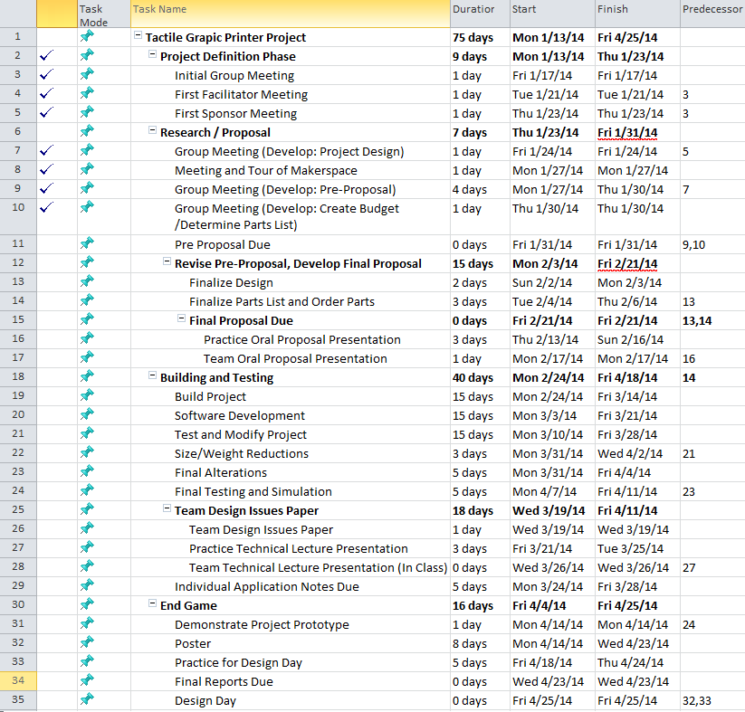

Budget
At first, the team decided to choose the ORD Bot Hadron 3D printer mechanical platform kit for this project, but after detailed research, the team figured that this ORD Bot kit does not meet the requirement. First of all, the price of the kit is $499, which is almost the total budget assigned. Next, it only has a platform area of 8x8 inches, which is smaller than the project required: 11x17 inches. Last, this kit is not customizable. For instance, since the printer is designed to print out tactile graphic, instead of using the full Z axis, it may only need a part of it, which could save the budget also.
Since the project is basically to build a 3D printer, after evaluating all the options, the team came to a conclusion that $500 budget would not be sufficient for us, so the team asked for a budget extension and got approved with a new budget of $950. The team’s final budget is shown in the table. The core part is Shapeoko mechanical kit ($299), which is a simple, low cost, open source CNC milling machine kit. It also allows the team to add their own electronics and the corresponding pulleys, belts, and M3 hardware. The makeslide is an aluminum extrusion with two special V-shaped rails for wheels to roll on. The price of it is $32.84, the length of it is 1800mm, which allowed the team to cut it into segment to build the X, Y and Z axis. The Flexible Elastic Rubber-like Filament 500g ABS filament (EXPERIMENTAL) cost the team $67.75. The reason why the team chooses this filament is because as it mentioned in project goal, if possible, the deposited material will be elastic. This elastic-like or flexible filament is a super elastic type filament, which is great material for tactile graphics and maps. The ramps 1.4 kit is $189, which include one Arduino Mega 2560, four Stepper Drivers with heat sinks, a 4-pin pluggable terminal block and a 24 pin header and a loose 2nd diode. The 110V AC to 12V DC 10Amp Power Supply cost the team $42.34. The Interior Setting Voltage is: 13.8V +/- 0.1V Input: 110V-240V Output: DC 12V 10Amp Length: 150mm (5.9") Width: 80mm (3.15"). The EZStruder Cold End Kit cost us 35$, this cold end kit is compatible with any groove mount style hot end in either 1.75 or 3mm sizes as well as for 1.75mm Bowden setups using the included CNC machined Bowden adapter for use with our 4mm PTC fittings or any fitting that uses m5-8 threads. The J-head MK V-BV .35mm Kit for 3mm Filament includes J-Head hot end, resister, thermistor, liners, heat shrink,18 gauge appliance wire, predominated thermistor wire and a small pack muffler putty. The price of this whole kit is $69.95. The stepper motor cost the team $51.96, it is a general motor that useful for smaller and light-load applications. The team decided to use a griddle as heat bed, which approximately cost $30. The price of end plate is $7.89, the team needs 4 of them, so the total price is $31.56. The price of Motor Mount is $9.13, the team also needs 4 of them, and the total price is $36.52. These parts allow the team to easily expand the machine in the X direction and make scaling in both directions. The GT2 pulley and GT2 belt cost $12.94 and $5.97, respectively. The pulley is intended to be used in conjunction with GT2 belting. The V wheel, idler, leadscrew nut and eccentric spacer are $3.85, $19.40 , $4.75 and $2 respectively. These parts are used to be used with V-slot extrusion or open rail. For the glass, the Lansing Makers Space had one 11x17 sheet prepared for the team, it is 1/8th inch thick, double-strength, the cost of it is $0. The total cost of the project is $947.83 (see table 3).

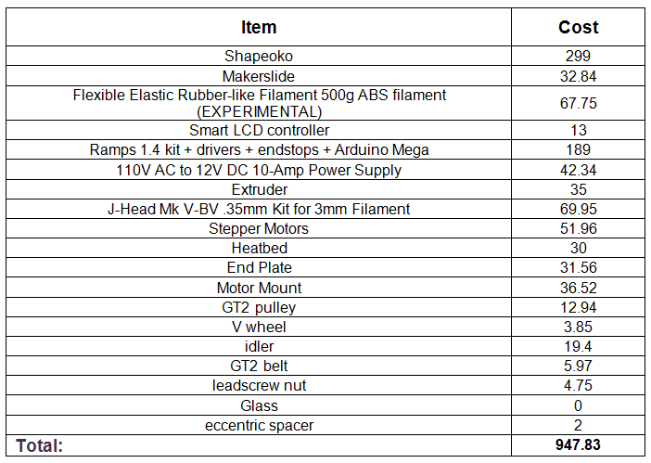
Table 3. Total Budget

References

3D Printing: Mashable. n.d. 30 January 2014 <http://mashable.com/category/3d-printing/>.
"Additive: Rapid." 2014. Rapid. 30 January 2014 <rapid.sme.org/2014/CUSTOM/Uploads/additive_handout>.

Electron Beam Freeform Fabrication: Wikipedia. 2 January 2014. 12 February 2014.
EM. "The Trade Magazine on Efficient Manufacturing." Februray 2013. Efficient Manufacturing. 27 January 2014 <http://www.efficientmanufacturing.in/pi-india/index.php?StoryID=443&articleID=129947>.

Fused Deposition Modeling: Wikipedia. 7 February 2014. 12 February 2014 <http://en.wikipedia.org/wiki/Fused_deposition_modeling>.

Laminated Object Manufacturing: Wikipedia. 2 February 2014. 12 February 2014 <http://en.wikipedia.org/wiki/Laminated_object_manufacturing>.

Machining: Wikipedia. 18 February 2014. 19 February 2014 <http://en.wikipedia.org/wiki/Machining>.

Stereolithography: Wikipedia. 9 February 2014. 12 February 2014 <http://en.wikipedia.org/wiki/Stereolithography>.

